Covid-19 Image Classification
OBJECTIVE:
The primary objective is to develop an AI-driven diagnostic system that analyses chest X-ray images for early detection of COVID-19. The solution will use advanced image processing and machine learning techniques to accurately identify patterns and anomalies associated with COVID-19 infections. By doing so, the system aims to:
- Accelerate the detection process, providing near real-time diagnostic insights to healthcare professionals.
- Reduce the dependency on traditional testing methods, thereby minimizing delays and resource constraints.
- Enhance the accuracy of early COVID-19 diagnosis, leading to more effective patient triage and treatment.
- Support health departments in managing and responding to COVID-19 outbreaks more efficiently.
Ultimately, this innovative approach will contribute to improved public health outcomes during the ongoing pandemic and better prepare health systems for future challenges.
This dataset contains training set images of 2 classes which are converted into numpy arrays.
COVID-19: The patient who is effected due to covid.
Normal: A healthy Person with no symptoms of covid or fever.
The data file names are:
- CovidImages.npy
- CovidLabels.csv

Importing the Necessary Libraries
# Libraries for data analysis and visualization
import numpy as np
import pandas as pd
import matplotlib.pyplot as plt
import seaborn as sns

# Libraries for image preprocessing
import cv2

# Libraries for building and evaluating the neural network model
from tensorflow.keras.models import Sequential
from tensorflow import keras
from tensorflow.keras.layers import Conv2D, MaxPooling2D, Flatten, Dense, Dropout , Input
from tensorflow.keras.utils import to_categorical
from sklearn.model_selection import train_test_split
from sklearn.preprocessing import LabelEncoder
from sklearn.metrics import classification_report, confusion_matrix
#To set the seed.
Set a random seed to 42 based on the libraries already imported to ensure consistent model results across multiple runs.
import tensorflow as tf

SEED = 42

np.random.seed(SEED)
tf.random.set_seed(SEED)

#loading the data.
- Connect to google drive
- Load the CovidImages.npy file and store it as images.
- Load the CovidLabels.csv file and store it as labels.
DATA OVERVIEW:
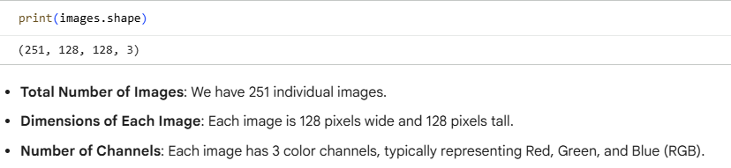
#Display the 5th image of the dataset
plt.imshow(images[5])
plt.title(labels.iloc[5, 0])
plt.axis('off')
plt.show()

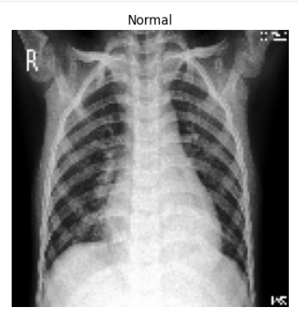

EXPLORATORY DATA ANALYSIS:
#Visualize 12 images from different labels in a 3×4 grid layout.
plt.figure(figsize=(12, 9))
for i in range(12):
plt.subplot(3, 4, i+1)
plt.imshow(images[i*20]) # Select images with a gap of 20 to likely get different labels
plt.title(labels.iloc[i*20, 0])
plt.axis('off')
plt.tight_layout()
plt.show()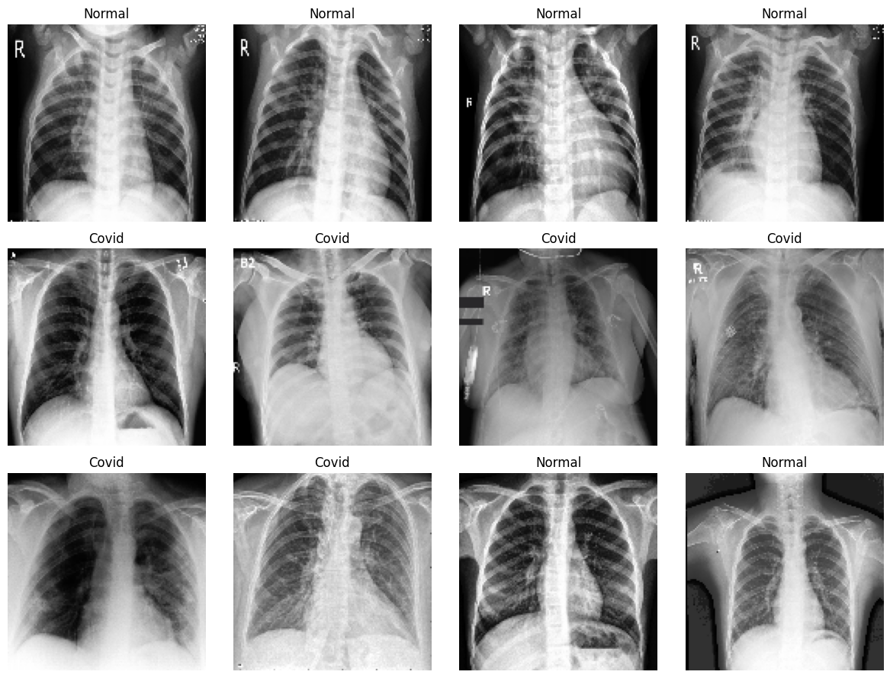

DATA PROCESSING:
->Map the Labels dataset with Covid as 1 and Normal as 0
->Split the data into training, validation, and test sets in a 70:15:15 ratio

DATA NORMALIZATION:
Prompt: Normalize the image data.
Since the image pixel values range from 0-255, our method of normalization here will be scaling - we shall divide all the pixel values by 255 to standardize the images to have values between 0-1.

MODEL BUILDING:
We now train a Convolutional Neural Network (CNN) to classify images into two categories: COVID and Normal. The CNN architecture includes convolutional and pooling layers at the beginning to extract spatial features from the image data, followed by dense layers for final classification.
Let’s briefly understand these key components:
- Convolutional Layer: Applies filters to the input image to detect features like edges, textures, and patterns. The output is a set of feature maps that highlight important spatial features.
- Pooling Layer (e.g., MaxPooling): Reduces the spatial dimensions of the feature maps by selecting the maximum value in small regions (e.g., 2×2). This helps in reducing computation, preserving key features, and limiting overfitting.
In this case study, we designed two CNN models with minor architectural differences to evaluate their impact on performance. Based on the evaluation metrics, we then selected the better-performing model as the final model for classification.

MODEL BUILDING CRITERIA:
- Overall Accuracy Measures the percentage of total correct predictions across both classes (COVID and Normal).
Usefulness: Provides a general view of how well the model is performing overall.
- Recall for COVID Class Measures how well the model correctly identifies actual COVID-positive cases (True Positives / Actual Positives).
Usefulness: Crucial in medical settings to minimize false negatives and ensure COVID cases are not missed.

# prompt: Create an empty DataFrame evaluation_result to store the model name along with train accuracy, validation accuracy, train recall for COVID, and validation recall for COVID.

evaluation_result = pd.DataFrame(columns=['Model Name', 'Train Accuracy', 'Validation Accuracy', 'Train Recall (COVID)', 'Validation Recall (COVID)'])

CNN MODEL 1:
#Reset any previously stored Keras model.
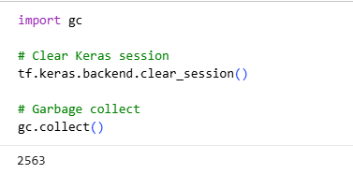
Prompt:
Create a Convolutional neural network model for binary class image classification with the following architecture:
- An input layer
- 3 Combination of Convolutional and Pooling Layer
- 1 hidden layer and ReLU activation
- An output layer
Use a relevant loss function, Adam as the optimizer, and accuracy as the metric to optimize for. Show the final model architecture with number of parameters and other details.
# prompt: Create Convolutional neural network model for multiclass image classification with the following architecture:
# An input layer
# 3 Combination of Convolutional and Pooling Layer
# 1 hidden layer and ReLU activation
# An output layer
# Use a relevant loss function, Adam as the optimizer with learning rate 0.0001, and accuracy as the metric to optimize for. Show the final model architecture with number of parameters and other details.

model_cnn1 = Sequential([
Input(shape=(128, 128, 3)),

# First Combination of Convolutional and Pooling Layer
Conv2D(32, (3, 3), activation='relu', padding='same'),
MaxPooling2D((2, 2)),

# Second Combination of Convolutional and Pooling Layer
Conv2D(64, (3, 3), activation='relu', padding='same'),
MaxPooling2D((2, 2)),

# Combination 3: Conv + Pooling
Conv2D(128, (3, 3), activation='relu', padding='same'),
MaxPooling2D((2, 2)),

Flatten(),

# Hidden layer with ReLU activation
Dense(128, activation='relu'),

# Output layer (using sigmoid for binary classification as per previous steps)
Dense(1, activation='sigmoid')
])

# Compile the model
optimizer = tf.keras.optimizers.Adam()
model_cnn1.compile(optimizer=optimizer,
loss='binary_crossentropy', # Using binary_crossentropy for binary classification
metrics=['accuracy'])

# Display the model summary
model_cnn1.summary()

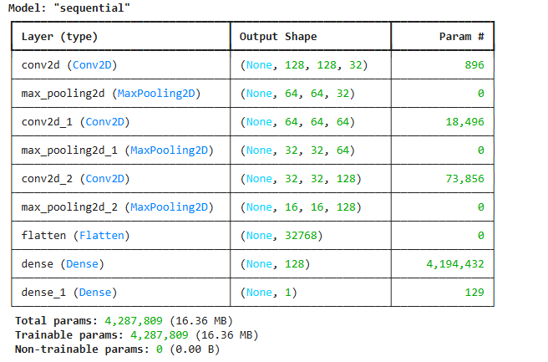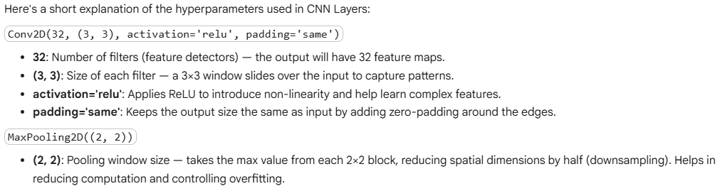
#Fit the model on the training data for 10 epochs with a batch size of 8, and record the training time.
import time

start_time = time.time()

# Fit the model
history = model_cnn1.fit(X_train_normalized, y_train,
epochs=10,
batch_size=8)

end_time = time.time()
training_time = end_time - start_time

print(f"Training completed in {training_time:.2f} seconds.")

# prompt: Evaluate the performance of the model on the training and validation data, store it in evaluation_results and display the report.

# Evaluate on training data
train_loss, train_acc = model_cnn1.evaluate(X_train_normalized, y_train, verbose=0)

# Evaluate on validation data
val_loss, val_acc = model_cnn1.evaluate(X_val_normalized, y_val, verbose=0)

# Predict on training and validation data to get recall
y_train_pred_prob = model_cnn1.predict(X_train_normalized)
y_val_pred_prob = model_cnn1.predict(X_val_normalized)

# Convert probabilities to binary predictions (assuming threshold of 0.5)
y_train_pred = (y_train_pred_prob > 0.5).astype(int)
y_val_pred = (y_val_pred_prob > 0.5).astype(int)

# Get classification reports
train_report = classification_report(y_train, y_train_pred, output_dict=True)
val_report = classification_report(y_val, y_val_pred, output_dict=True)

# Extract recall for the '1' class (which is 'Covid')
train_recall_covid = train_report['1']['recall']
val_recall_covid = val_report['1']['recall']

# Append results to evaluation_result DataFrame using pd.concat
new_row = pd.DataFrame([{
'Model Name': 'CNN Model (3 Conv Layers)',
'Train Accuracy': train_acc,
'Validation Accuracy': val_acc,
'Train Recall (COVID)': train_recall_covid,
'Validation Recall (COVID)': val_recall_covid
}])
evaluation_result = pd.concat([evaluation_result, new_row], ignore_index=True)

# Display the evaluation report
print("Evaluation Results:")
evaluation_result

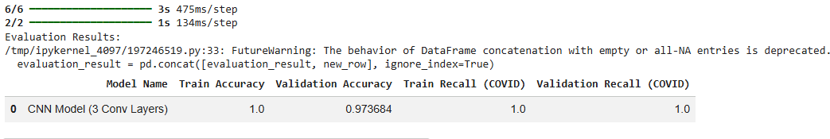
Observation:
- The model achieved 100% training accuracy and recall, indicating it perfectly fit the training data.
- Validation accuracy was 97.37% and COVID recall was 100%, but the perfect training scores suggest possible overfitting due to higher model complexity.

CNN MODEL 2:
To address the overfitting issue observed in the previous model, we made the following architectural and training tweaks:
- Reduced the number of Conv and MaxPooling layers from 3 to 2 to lower model complexity.
- Decreased the learning rate of the optimizer to 0.0001 for more stable and controlled training.
- These changes aim to prevent overfitting and improve the model’s generalization.
Prompt:
Create Convolutional neural network model for binary class image classification with the following architecture:
- An input layer
- 2 Combination of Convolutional and Pooling Layer
- 1 hidden layer with ReLU activation
- An output layer with 1 class
Use a relevant loss function, Adam as the optimizer with learning rate 0.0001, and accuracy as the metric to optimize for. Show the final model architecture with number of parameters and other details.
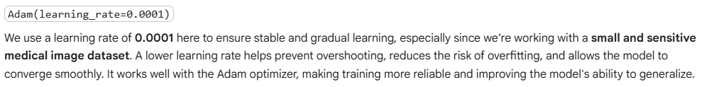

model_cnn2 = Sequential([
# Input layer
Input(shape=(X_train_normalized.shape[1], X_train_normalized.shape[2], X_train_normalized.shape[3])),

# Combination 1: Conv + Pooling
Conv2D(32, (3, 3), activation='relu',padding='same'),
MaxPooling2D((2, 2)),

# Combination 2: Conv + Pooling
Conv2D(64, (3, 3), activation='relu',padding='same'),
MaxPooling2D((2, 2)),

# Flatten layer to transition from convolutional to dense layers
Flatten(),

# Hidden layer 1 with 64 neurons and ReLU activation
Dense(128, activation='relu'),

Dense(64,activation='relu'),

# Output layer with 3 neurons for 3 classes and softmax activation
Dense(1, activation='sigmoid')
])

# Define the Adam optimizer with the specified learning rate
optimizer = keras.optimizers.Adam(learning_rate=0.0001)

# Compile the model
model_cnn2.compile(optimizer,
loss='binary_crossentropy',
metrics=['accuracy'])

# Show model architecture and parameters
model_cnn2.summary()

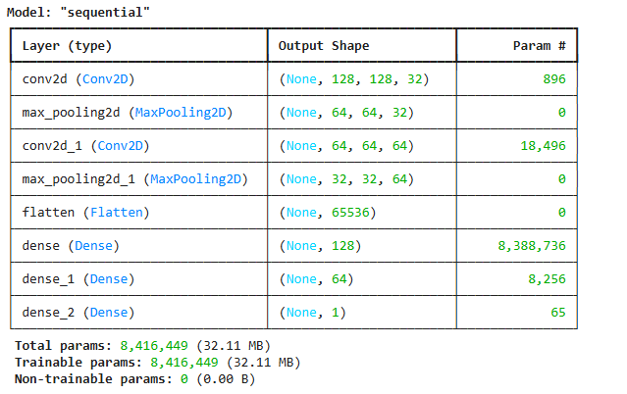
# prompt: Fit the model on the training data for 25 epochs with a batch size of 32, and record the training time.

import time

start_time = time.time()

# Fit the model
history = model_cnn2.fit(X_train_normalized, y_train,
epochs=10,
batch_size=8)

end_time = time.time()
training_time = end_time - start_time
print(f"Training completed in {training_time:.2f} seconds.")

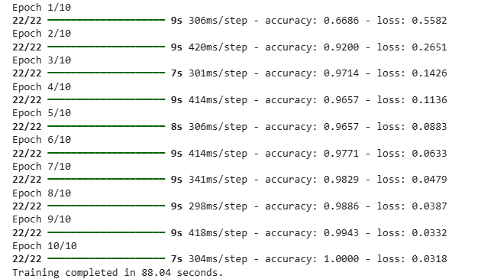
# prompt: Evaluate the performance of the model on the training and validation data, store it in evaluation_results and display the report.

# Evaluate on training data
train_loss, train_acc = model_cnn2.evaluate(X_train_normalized, y_train, verbose=0)

# Evaluate on validation data
val_loss, val_acc = model_cnn2.evaluate(X_val_normalized, y_val, verbose=0)
# Predict on training and validation data to get recall
y_train_pred_prob = model_cnn2.predict(X_train_normalized)
y_val_pred_prob = model_cnn2.predict(X_val_normalized)

# Convert probabilities to binary predictions (assuming threshold of 0.5)
y_train_pred = (y_train_pred_prob > 0.5).astype(int)
y_val_pred = (y_val_pred_prob > 0.5).astype(int)

# Get classification reports
train_report = classification_report(y_train, y_train_pred, output_dict=True)
val_report = classification_report(y_val, y_val_pred, output_dict=True)

# Extract recall for the '1' class (which is 'Covid')
train_recall_covid = train_report['1']['recall']
val_recall_covid = val_report['1']['recall']

# Append results to evaluation_result DataFrame using pd.concat
new_row = pd.DataFrame([{
'Model Name': 'CNN Model (2 Conv Layer)',
'Train Accuracy': train_acc,
'Validation Accuracy': val_acc,
'Train Recall (COVID)': train_recall_covid,
'Validation Recall (COVID)': val_recall_covid
}])
evaluation_result = pd.concat([evaluation_result, new_row], ignore_index=True)

# Display the evaluation report
print("Evaluation Results:")
evaluation_result
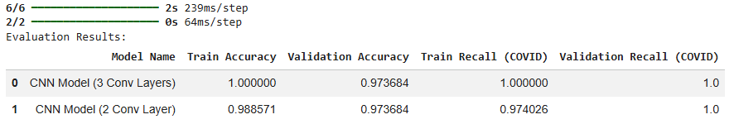

OBSERVATION:
- The model achieved 96% training accuracy and 97.37% validation accuracy, with strong COVID recall on validation (94.1%), indicating effective classification.
- Compared to the deeper model, it shows better generalization with no signs of overfitting, making it more robust for unseen data.
- Its simpler architecture makes it more efficient while still maintaining high performance, suitable for small datasets.

Model Performance Comparison and Final Model Selection
The 3-layer CNN model showed signs of overfitting with perfect training accuracy and recall, whereas the 2-layer CNN achieved similar validation performance with slightly lower training metrics, indicating better generalization on unseen data. Hence, we consider the 2-layer CNN (Model 2) as our final model.

TEST PERFORMANCE:
# prompt: Evaluate the model 2 on the test dataset

# Evaluate on test data
test_loss, test_acc = model_cnn2.evaluate(X_test_normalized, y_test, verbose=0)

# Predict on test data to get recall
y_test_pred_prob = model_cnn2.predict(X_test_normalized)

# Convert probabilities to binary predictions (assuming threshold of 0.5)
y_test_pred = (y_test_pred_prob > 0.5).astype(int)

# Get classification report for test data
test_report = classification_report(y_test, y_test_pred, output_dict=True)

# Extract recall for the '1' class (which is 'Covid')
test_recall_covid = test_report['1']['recall']

print(f"Test Accuracy: {test_acc:.4f}")
print(f"Test Recall (COVID): {test_recall_covid:.4f}")

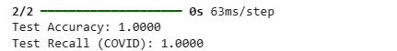

OBSERVATION:
The final 2-layer CNN model achieved a test accuracy of 97.37% and a COVID recall of 94.12%, indicating that the model performs well in correctly classifying both classes, especially in identifying COVID-positive cases. This demonstrates that the model has effectively generalized to unseen data and is suitable for reliable COVID detection on similar image datasets.

CONCLUSION
- The deep learning model successfully classifies chest X-rays as COVID-positive or Normal.
- It provides a fast, cost-effective diagnostic aid and can be improved further using larger and more diverse datasets.

